Sample Risk Assessment Template for Small and Medium Sized BC School Districts

How to Use This Template

This template is designed to help your district’s ERM Coordinator/Secretary-Treasurer and other district leaders apply a simple, consistent approach to assessing risks. It follows the steps outlined in the ERM Companion Guide and aligns with the ERM Framework for Small and Medium-Sized BC School Districts.

Each section prompts you to think through the core elements of a risk:
- What the risk is
- What causes it
- How likely it is to occur
- What the impacts could be
- How current controls influence the risk
- Whether the risk sits within or outside the district’s risk appetite
- What actions may be required

The goal is to create shared understanding, support informed decision-making, and provide a clear record of how the district is managing its priority risks.

Entries in this template should match those in your Risk Register and Risk Action Plan.

Comment bubbles alongside the template fields explain alignment with the other ERM Toolkit resources in this suite. Orange text/highlighted fields are only illustrative and should be deleted.

Implementation Tips
Use one template per unique risk.
- Start simple
  - Focus on a handful of meaningful risks at a time. Prioritize the areas that matter most for student learning, safety, and financial or operational stability.
- Use real examples and available evidence
  - Draw from incidents, audit findings, staff feedback, operational data, or known challenges.
- Use the district’s risk appetite as a guide
  - Risk appetite helps you judge whether a risk is acceptable or requires treatment; it is a reference point to support consistent decision-making.
  - If a risk appetite is not known (e.g. there isn’t one for this risk or it’s unclear). You can skip or omit this field.
- Document only what is needed to support decisions
  - Avoid long narratives. Clear, concise entries help you revisit and repeat assessments over time. They also ensure solid messaging for reporting.
- Review and refresh regularly
  - Risks change as programs, technology, budgets, and policy environments evolve. Consider updating assessments alongside budget development, strategic planning, or other annual cycles.
  - Re-assessment of certain risks may also be warranted when there are significant disruptions to the district’s operating environment, e.g. crisis events or ubiquitous new technologies like AI.

Risk Assessment Template
With sample text and guiding notes

1. Risk Identification
Risk ID (From the Risk Register) | R-2025-03
Risk Title (From the Risk Register) | Facility failure due to deferred maintenance
Risk Description – Explain how this uncertainty could impact the district’s objectives
Deferred maintenance could result in facility failure affecting student safety and operations.
Risk Category (from Framework categories) | Facilities & Infrastructure
Strategic Goal / Compliance Objective Affected | Student safety and well-being
Risk Owner (Department Lead) | Facilities Manager
Date Identified | 28-11-2025

2. Causes and Potential Impacts
Primary Causes (Risk Drivers) - Explain what could trigger this risk:
Aging facilities
Limited capital funding available
Reactive maintenance approach

Potential Impacts on the District - Explain, if any impact. Note, if no impact:
Student learning / FESL priorities | Disruption to learning environments
Financial stewardship | Increased long-term repair costs
Operations or service continuity | Emergency closures
Reputation / community trust | Parent skepticism of district’s planning
Compliance / safety obligations | Safety incidents or injuries

3. Baseline Assessment (Inherent Risk)
Complete this section before the risk action plan is implemented. Refer to the district’s ERM Framework for definitions of each option.

Likelihood Scale (Mark an X next to the appropriate rating)
Likelihood | Rating | Definition | Typical Timeframe / Example
 | 5  Almost Certain | Happens often; already occurring or part of operations. | Occurs every year or more (e.g., staff absences, IT interruptions).
X | 4  Likely | Has happened before and is likely to occur again. | Occurs at least once in 3–5 years (e.g., funding shortfall, minor system failure).
 | 3  Possible | Could occur under certain conditions, but not routine. | May occur once in 5–10 years (e.g., major facility repair, leadership turnover).
 | 2  Unlikely | Rare, though not impossible under unusual circumstances. | Could occur once in 10–20 years (e.g., long power outage, major policy change).
 | 1  Rare | Has not happened before; highly improbable. | Might occur once in 20–50 years (e.g., catastrophic building loss, severe natural disaster).

Impact Scale (Mark an X next to the appropriate rating)
Impact | Rating | Plain Definition | Typical Example
 | 5  Catastrophic | District-wide impact or severe harm to people, assets, or reputation. | School closure, injury, major data loss, or funding collapse.
X | 4  Major | Requires Board or Ministry attention; significant cost or service impact. | Extended program disruption, media coverage, or large repair cost.
 | 3  Medium | Short-term or localized issue; handled within current resources. | Temporary outage, facility repair, or moderate financial variance.
 | 2  Minor | Easily managed within school or department. | Brief service gap, small error, or short absence.
 | 1  Low | Negligible or no impact on people, operations, or finances. | Minor delay or inconvenience.

Inherent Risk Rating (Likelihood × Impact) | 4x4=16

Inherent Risk Level based on Inherent Risk Rating  (select one): |  | 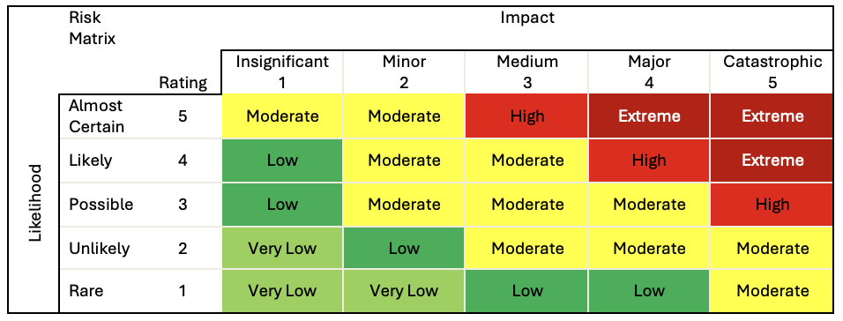
Very Low (1-2)
Low (3-4)
Moderate (5-12)
High (13-16) | X
Extreme (17-25)

4. Existing Controls
List what the district may already be doing to mitigate this risk, e.g. existing policies, processes, systems:
Annual facilities inspection
Work order tracking system
Safety compliance checks

Assessment of Control Effectiveness (select one):
Weak: Controls are not effective, inconsistent, or largely absent.
Developing: Controls exist but are not fully implemented or consistently applied.
Adequate: Controls are established, reliable, and generally effective in reducing the risk | X
Strong: Controls are well-designed, consistently applied, and regularly reviewed for effectiveness.

5. Risk Appetite Alignment
Relevant District Risk Appetite Statement (if available):
Student safety and well-being: We have no appetite for unmanaged risks that could harm students.

Does the inherent risk exceed appetite?
(select one):
Yes | X
No
Approaching
Unclear

Rationale:
Leadership has no appetite for this type of risk. The risk score is 16 (high); therefore, it exceeds leadership’s risk appetite.

6. Prioritization Decision
The district may choose to invest in further risk treatments (prioritize and develop a risk action plan) if the risk either approaches/exceeds risk appetite and/or has a high/extreme risk rating and/or has weak controls. Also, to inform this decision, contextual knowledge of your district’s goals, resources and operations should be considered.
Priority Level (select one):
Not a Priority
Monitor Only
Priority for Risk Action Plan | X

Decision Notes:
Due to the High risk score and no appetite for risk to student safety, the district will complete a Risk Action Plan for this risk to address both the likelihood and impact.

7. Residual Risk (Target rating after Risk Action Plan is implemented)
Complete this section after the risk action plan has been implemented.

Likelihood Scale (Mark an X next to the appropriate rating)
Residual Likelihood | Rating | Definition | Typical Timeframe / Example
 | 5  Almost Certain | Happens often; already occurring or part of operations. | Occurs every year or more (e.g., staff absences, IT interruptions).
 | 4  Likely | Has happened before and is likely to occur again. | Occurs at least once in 3–5 years (e.g., funding shortfall, minor system failure).
X | 3  Possible | Could occur under certain conditions, but not routine. | May occur once in 5–10 years (e.g., major facility repair, leadership turnover).
 | 2  Unlikely | Rare, though not impossible under unusual circumstances. | Could occur once in 10–20 years (e.g., long power outage, major policy change).
 | 1  Rare | Has not happened before; highly improbable. | Might occur once in 20–50 years (e.g., catastrophic building loss, severe natural disaster).

Impact Scale (Mark an X next to the appropriate rating)
Residual Impact | Rating | Plain Definition | Typical Example
 | 5  Catastrophic | District-wide impact or severe harm to people, assets, or reputation. | School closure, injury, major data loss, or funding collapse.
 | 4  Major | Requires Board or Ministry attention; significant cost or service impact. | Extended program disruption, media coverage, or large repair cost.
X | 3  Medium | Short-term or localized issue; handled within current resources. | Temporary outage, facility repair, or moderate financial variance.
 | 2  Minor | Easily managed within school or department. | Brief service gap, small error, or short absence.
 | 1  Low | Negligible or no impact on people, operations, or finances. | Minor delay or inconvenience.

Residual Risk Rating (Likelihood × Impact) | 3x3=9

Residual Risk Level based on Residual Risk Rating
(select one):
Very Low (1-2)
Low (3-4)
Moderate (5-12) | X
High (13-16)
Extreme (17-25)

Does the residual risk exceed appetite?
(select one):
Yes | X
No
Approaching
Unclear

8. Review & Monitoring Notes
Consider aligning review dates with your district’s other reporting, planning and/or decision-making processes.

Review Frequency (select one):
Quarterly
Semi-Annual | X
Annual
Other

Next Review Date | 28-07-2026
Reviewer(s) | ERM Coordinator, Facilities Manager

Monitoring Notes:
Next review date allows time for development of the Risk Action Plan and a mid-budget cycle review. Findings from this review will determine recommendations for next budget planning period.

- End of document -

